**CREATE FIRST VPC IN MUMBAI REGION :**

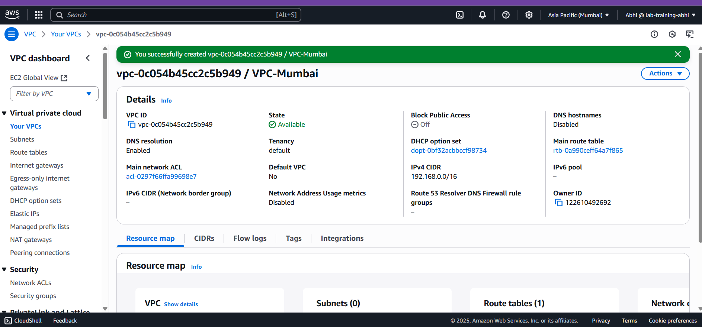

**CREATE THE SECOND VPC IN OSAKA REGION :**

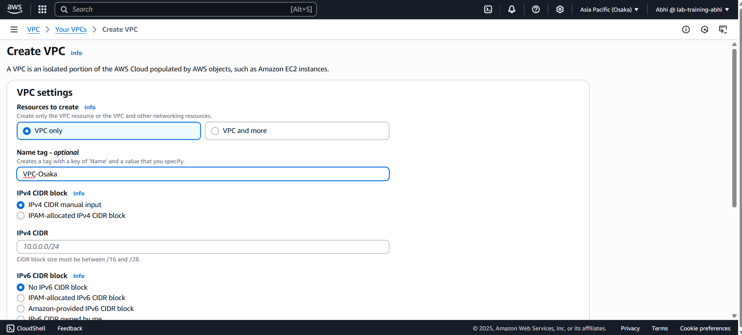

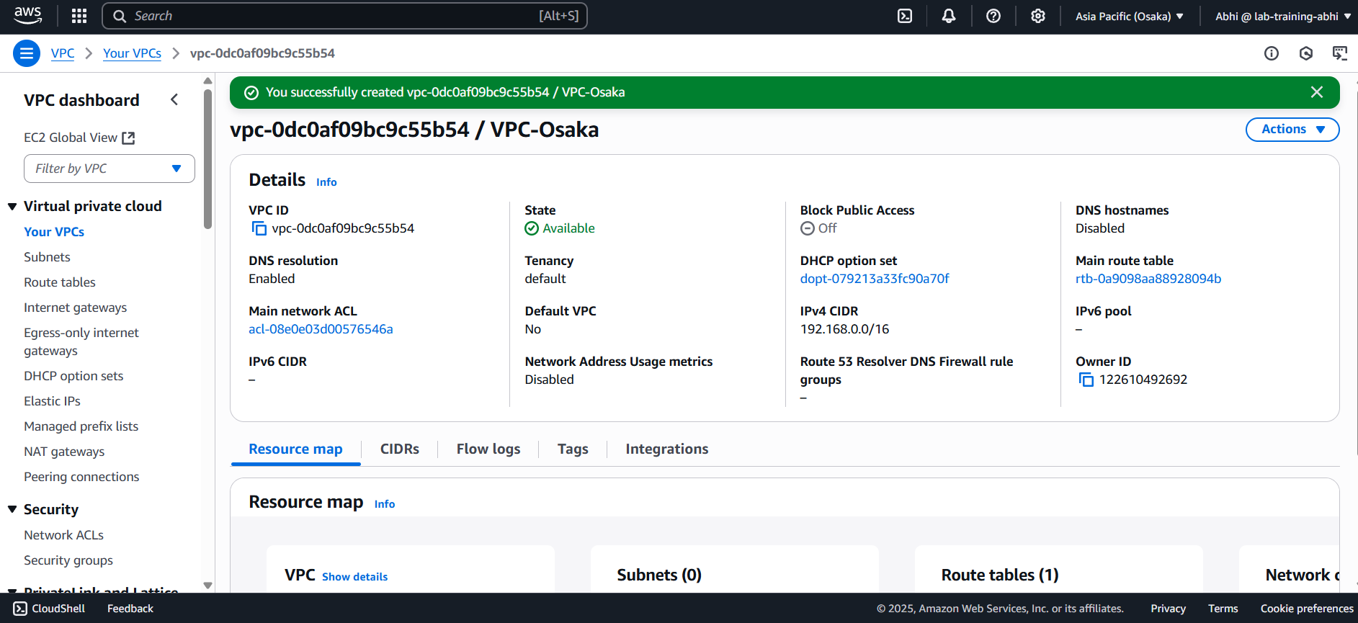

**CREATE THE SUBNET IN VPC-MUMBAI IN MUMBAI REGION :**

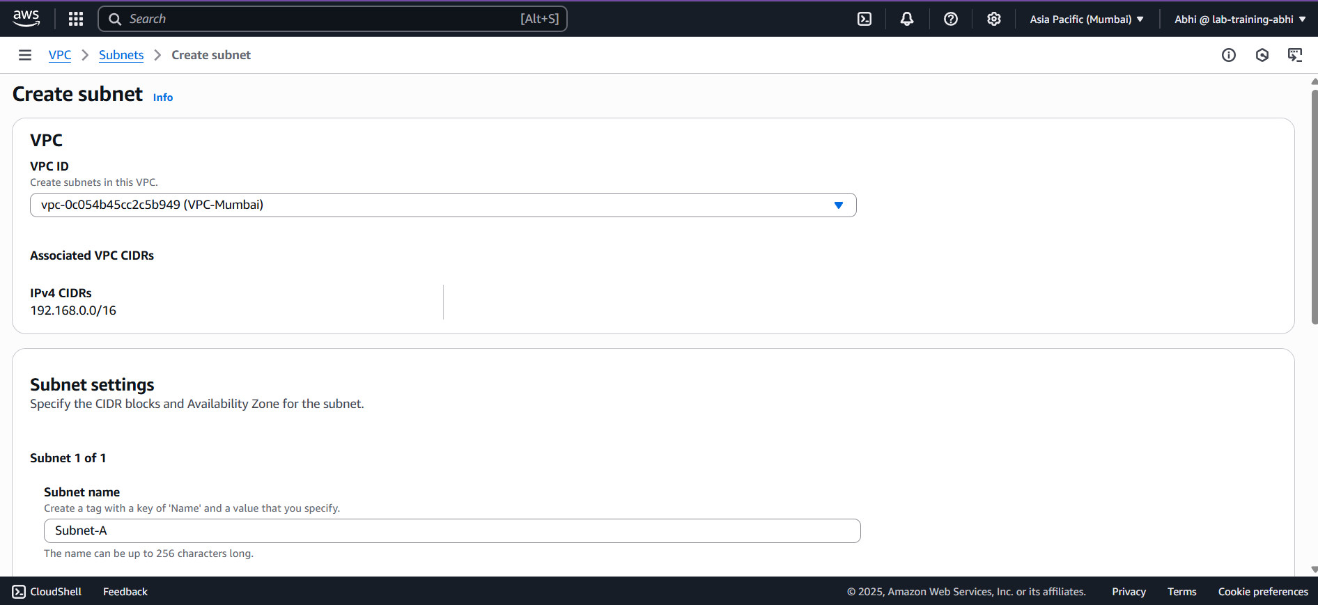

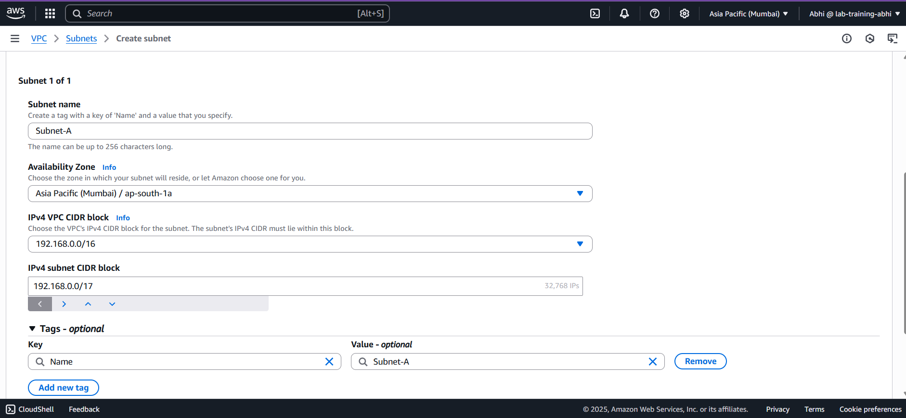

**SUCCESSFULLY CREATED THE SUBNET IN MUMBAI REGION :**

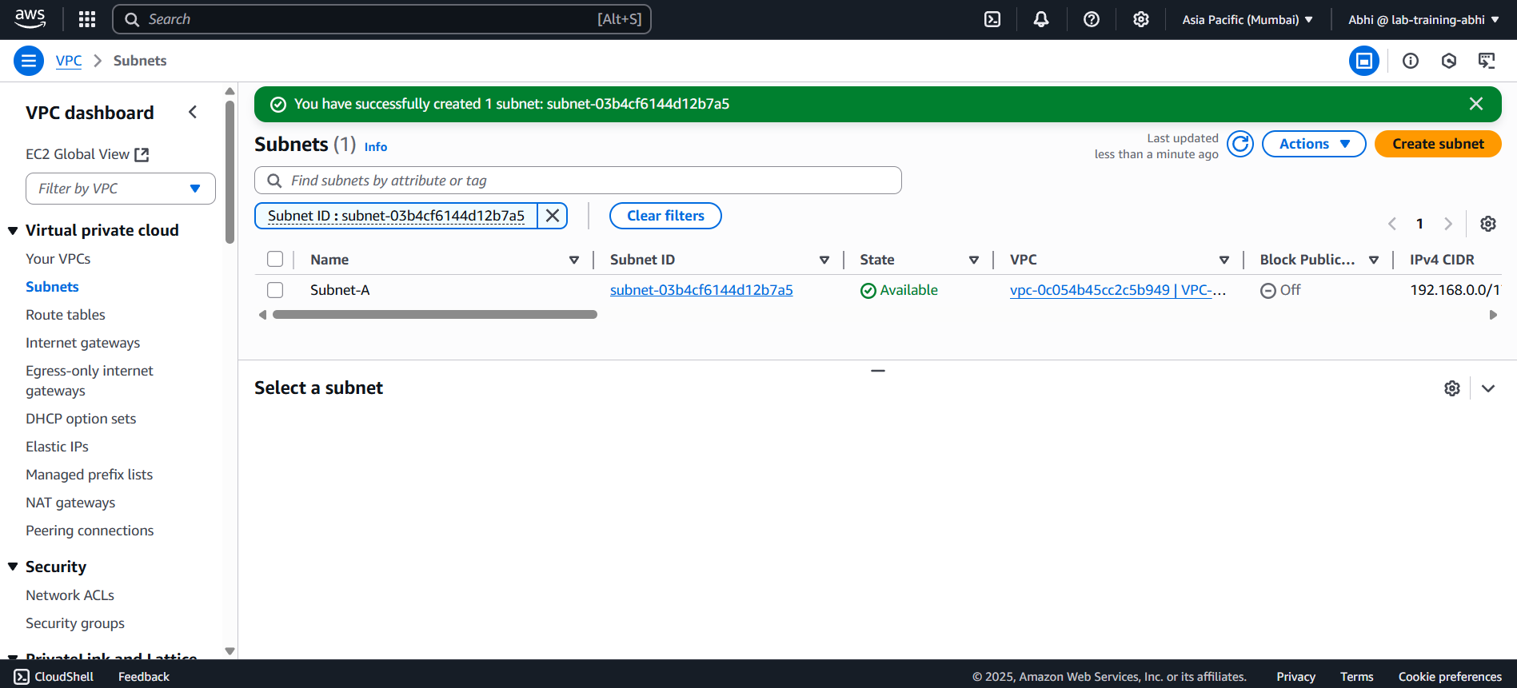

**CREATE THE SECOND SUBNET FOR VPC-OSAKA IN OSAKA REGION :**

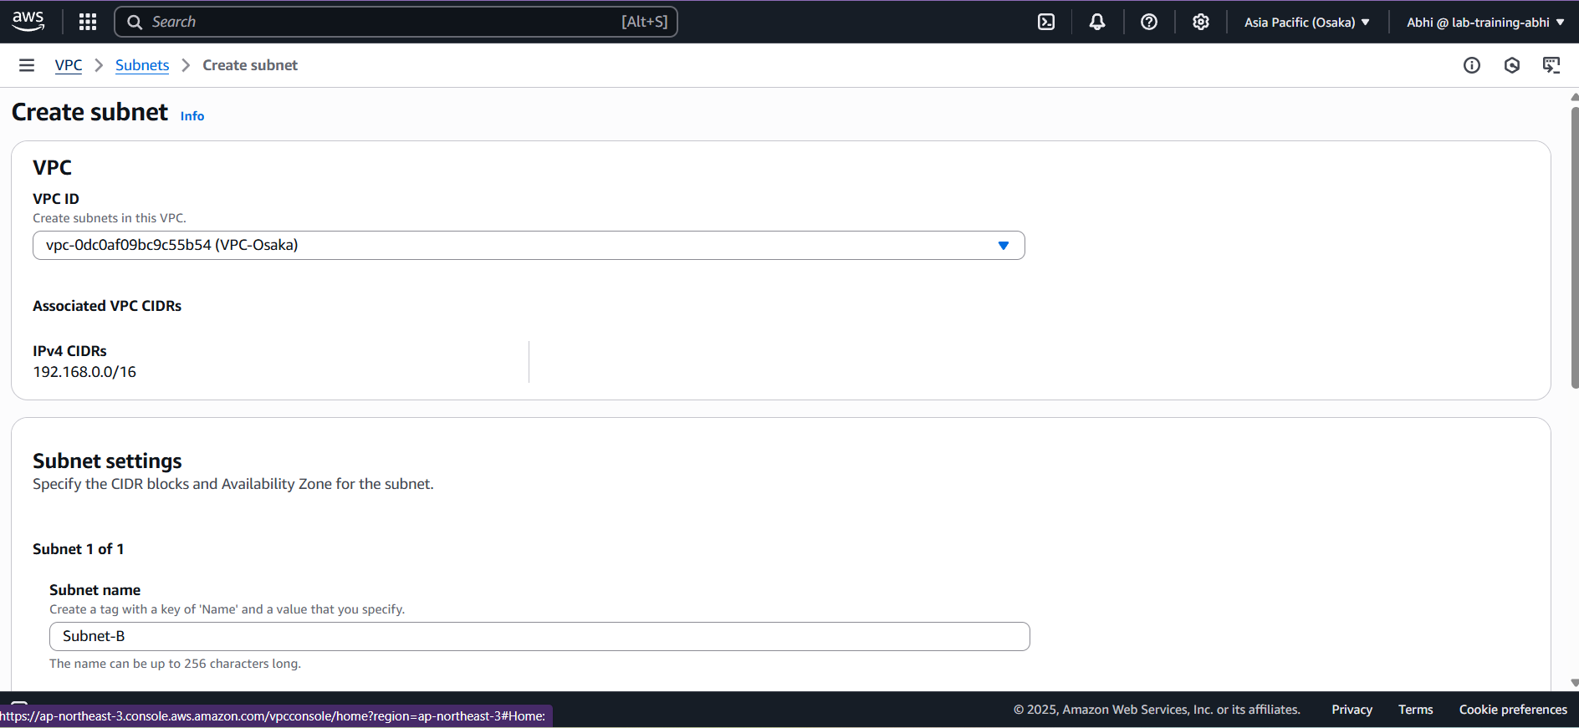

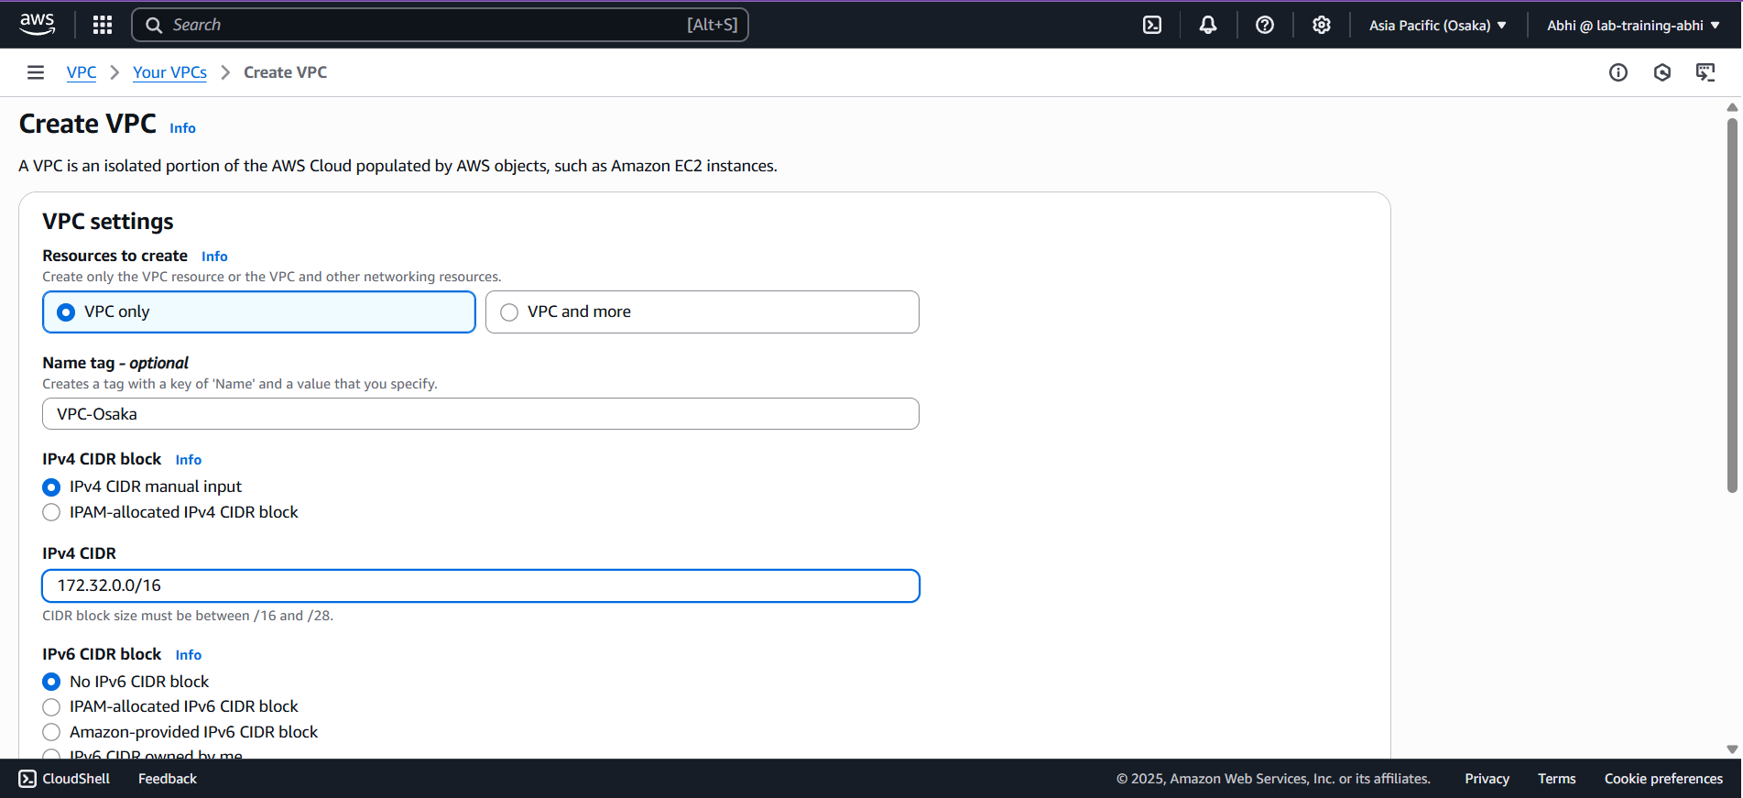

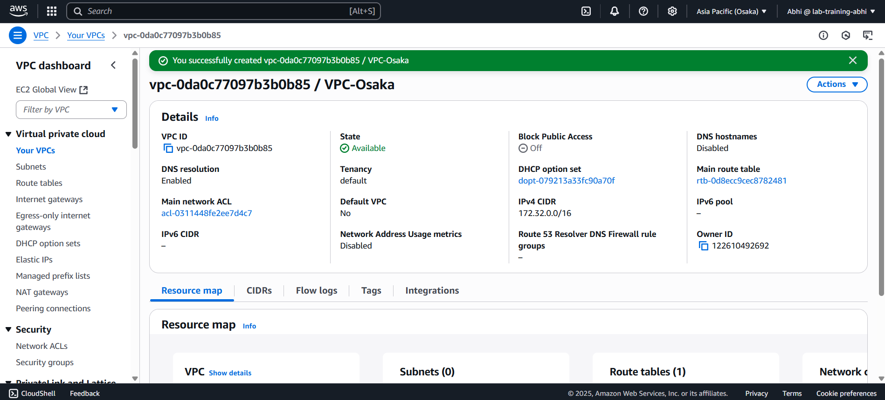

**CREATE THE SUBNET IN OSAKA REGION :**

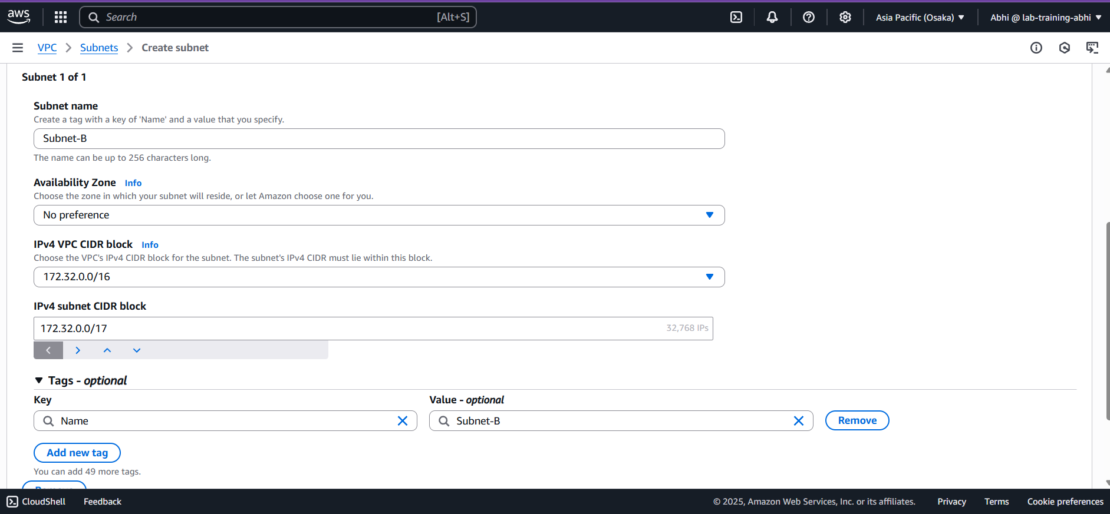

**CREATE THE INTERNET GATEWAY FOR VPC-MUMBAI IN MUMBAI REGION :**

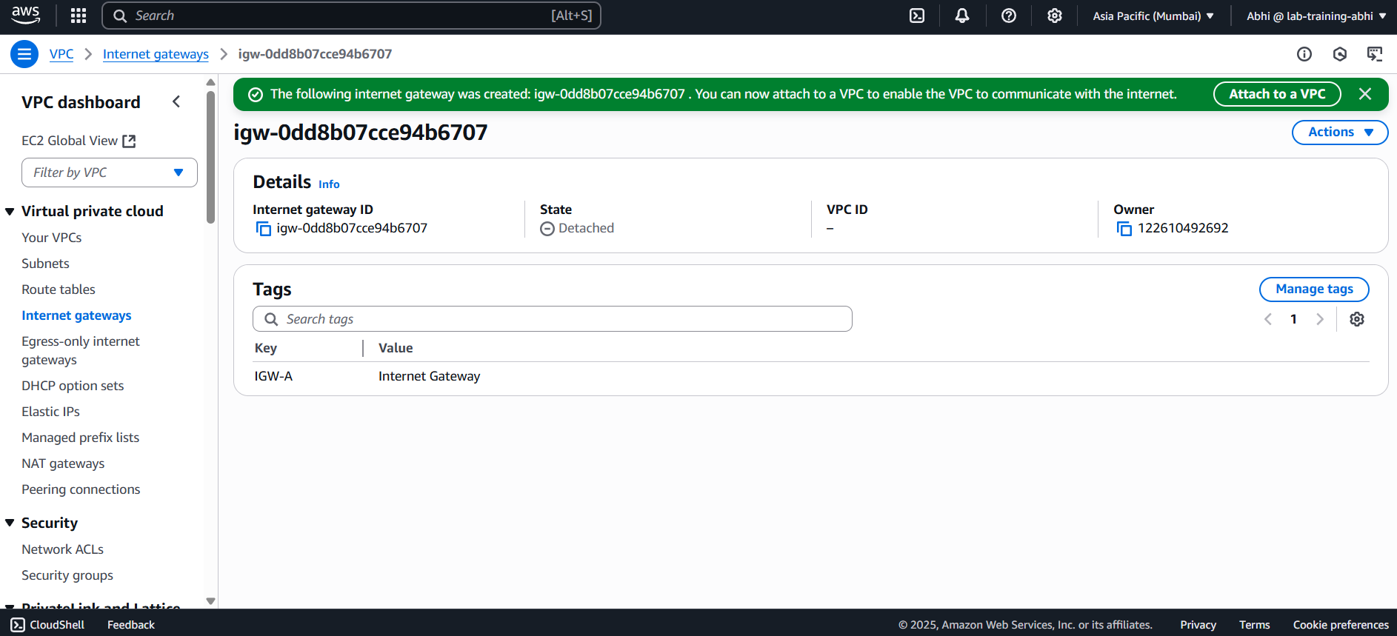

**ATTACH THE INTERNET GATEWAY TO VPC-MUMBAI :**

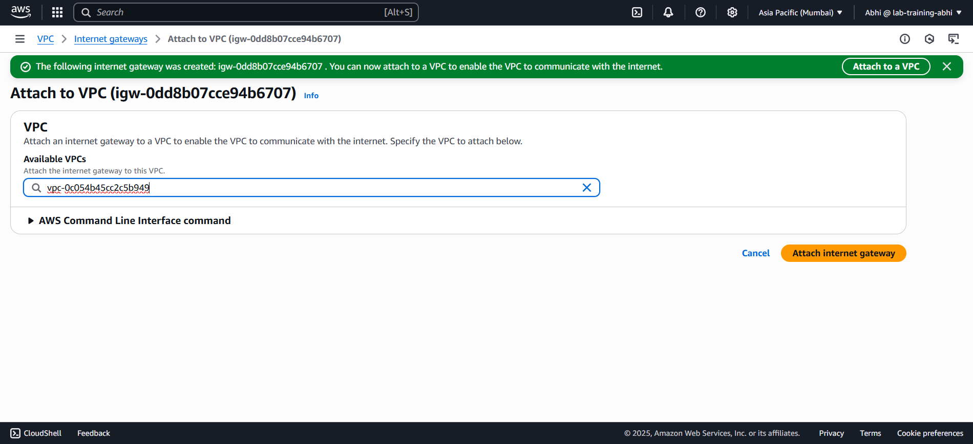

**ATTACHED THE INTERNET GATEWAY TO VPC-MUMBAI :**

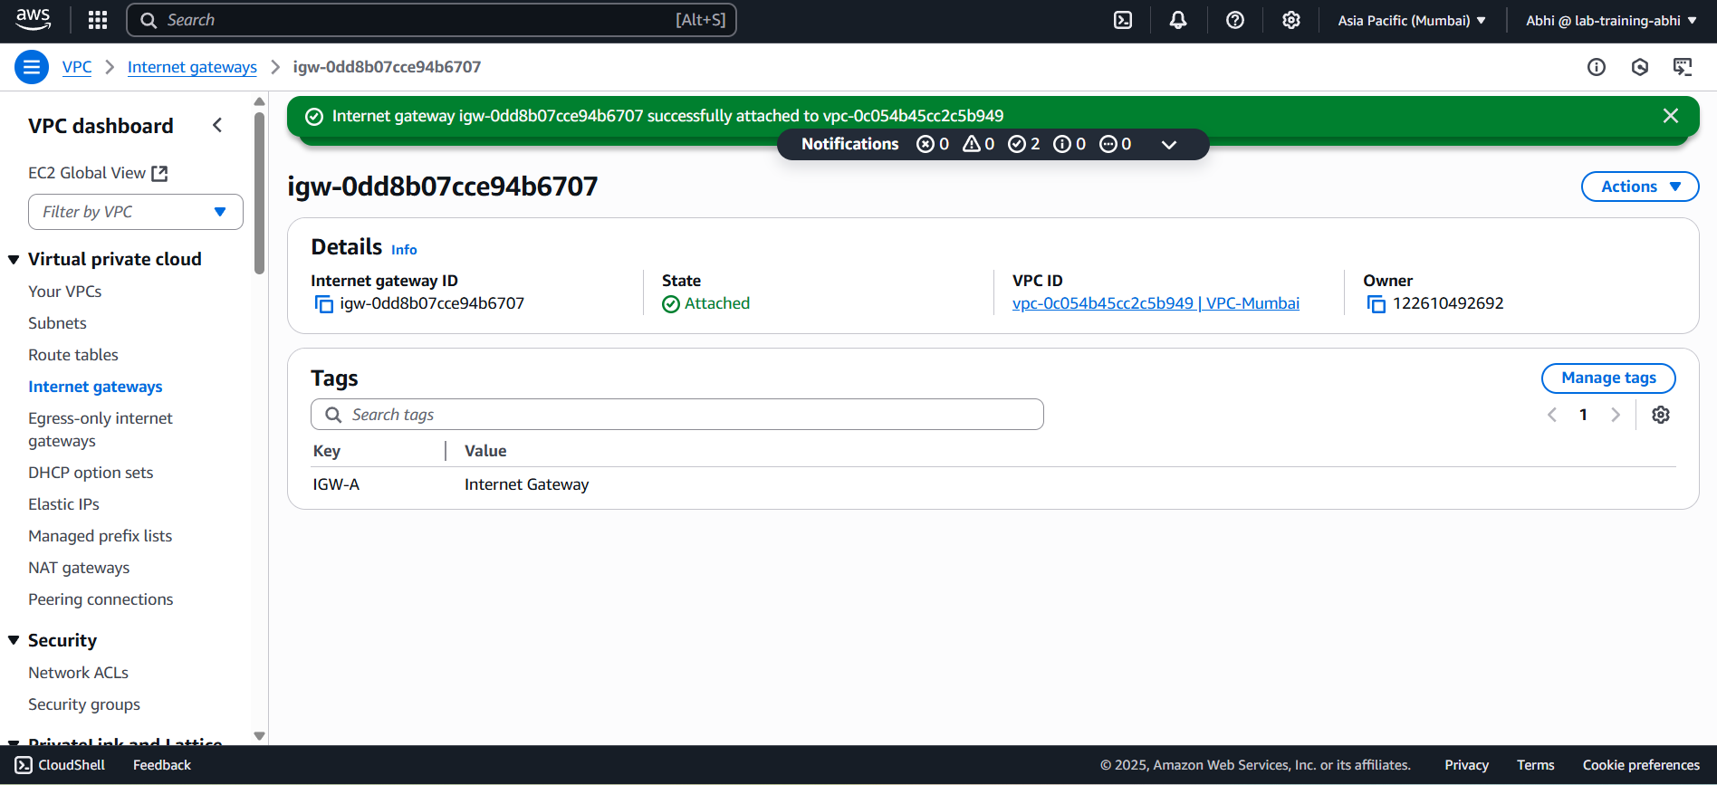

**CREATE A PEERING CONNECTION :**

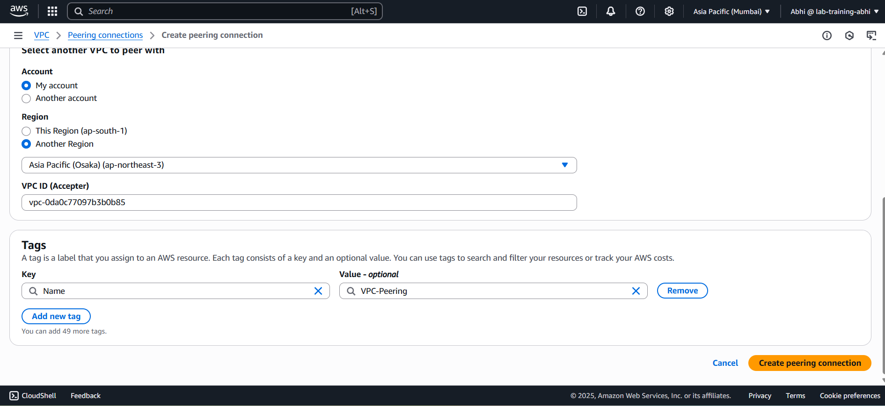

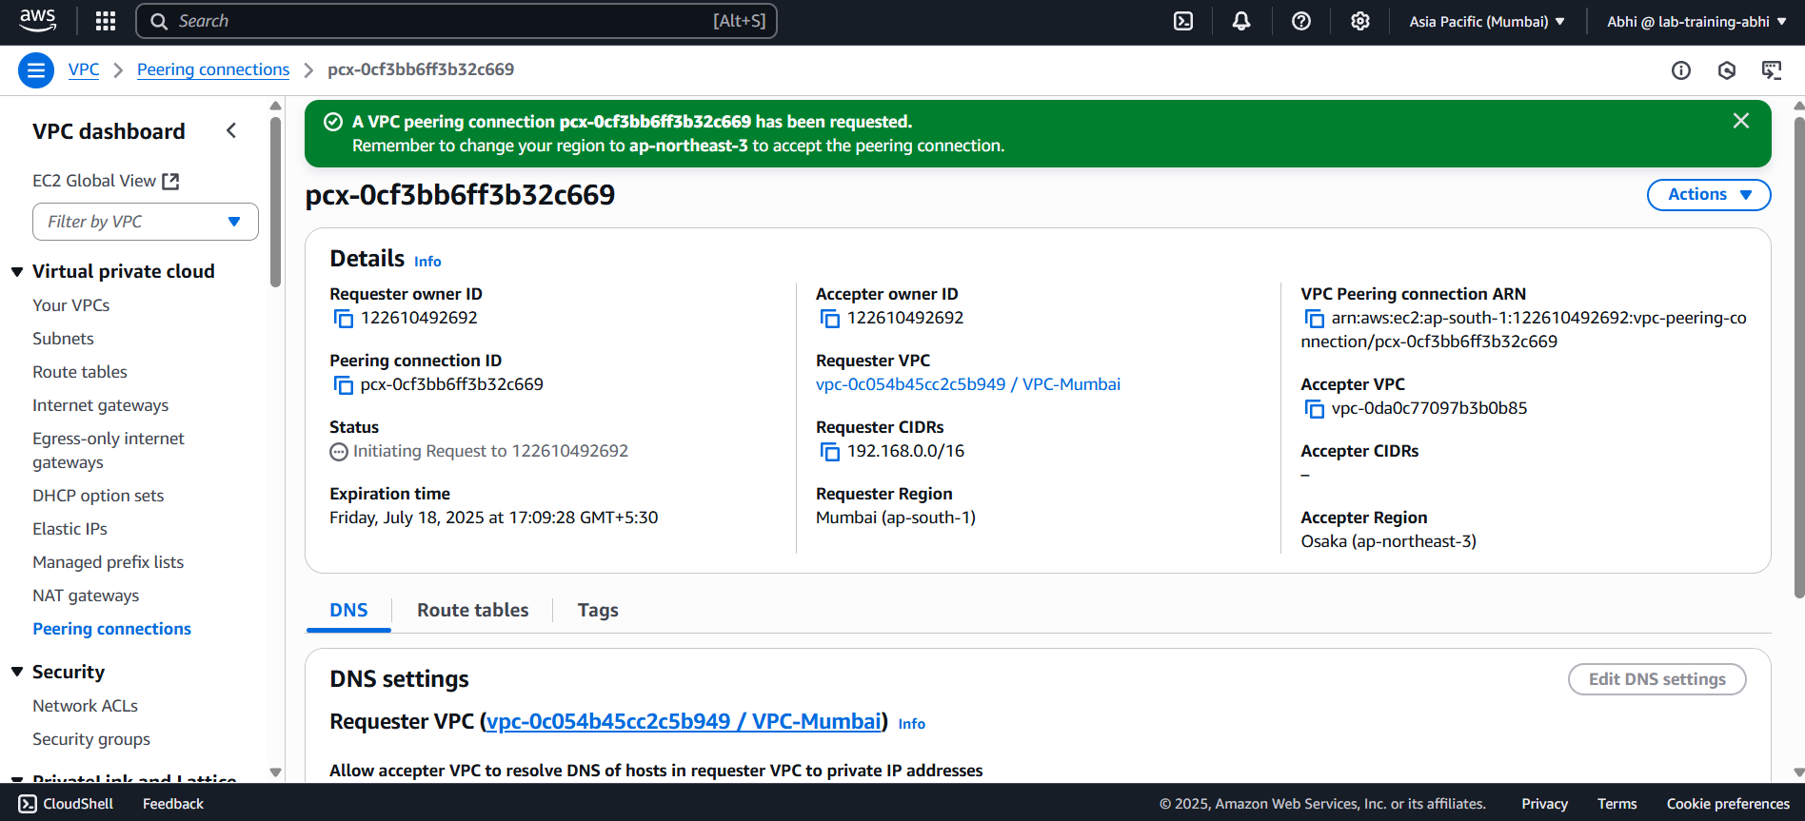

**CHECKING THE STATUS OF THE PEERING REQUEST :**

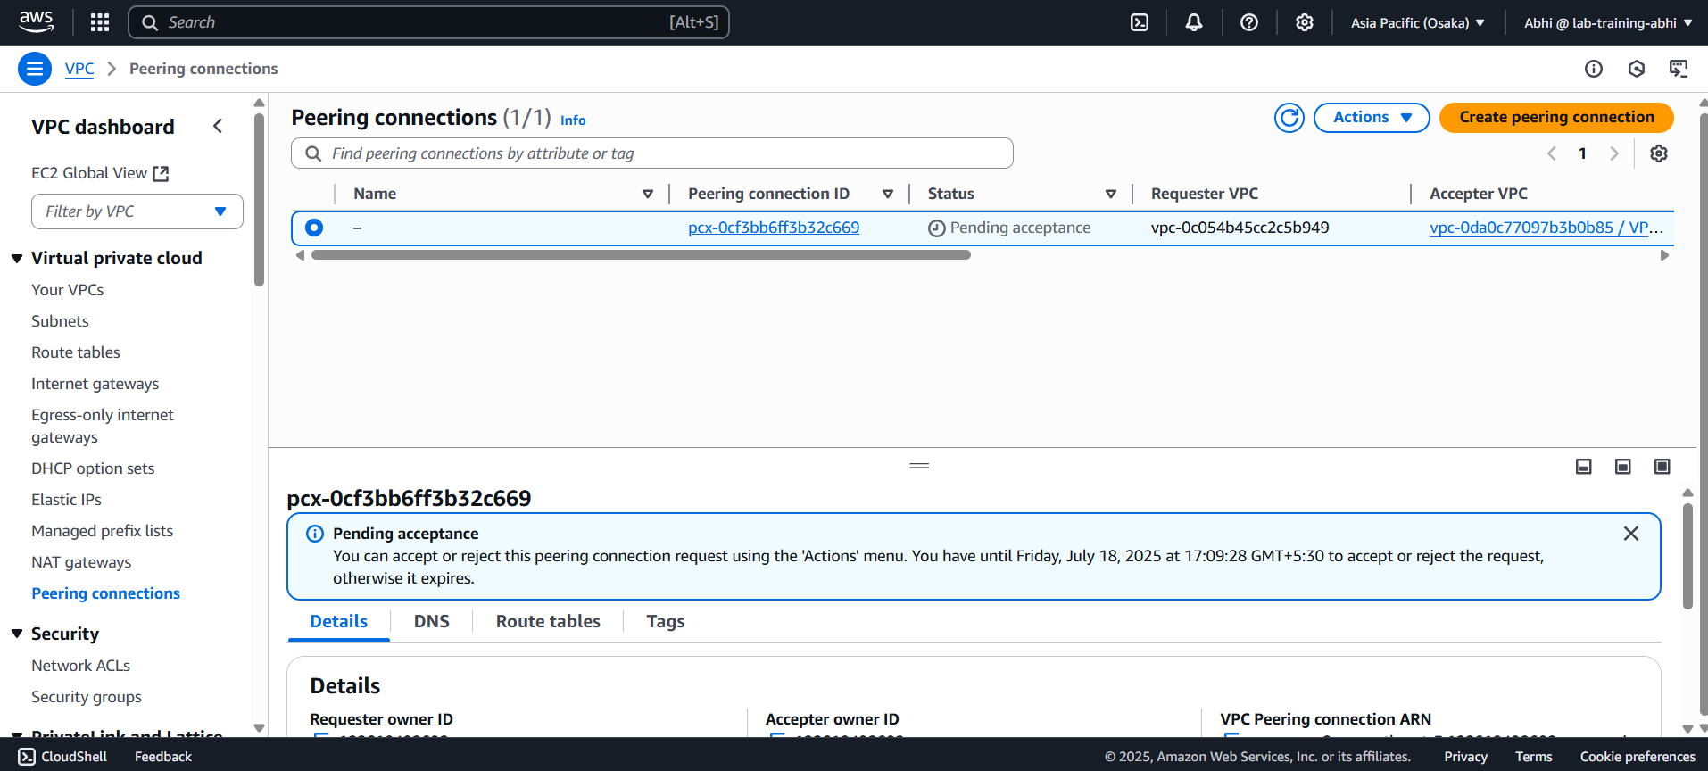

**ACCPET THE PEERING REQUEST IN OSAKA REGION :**

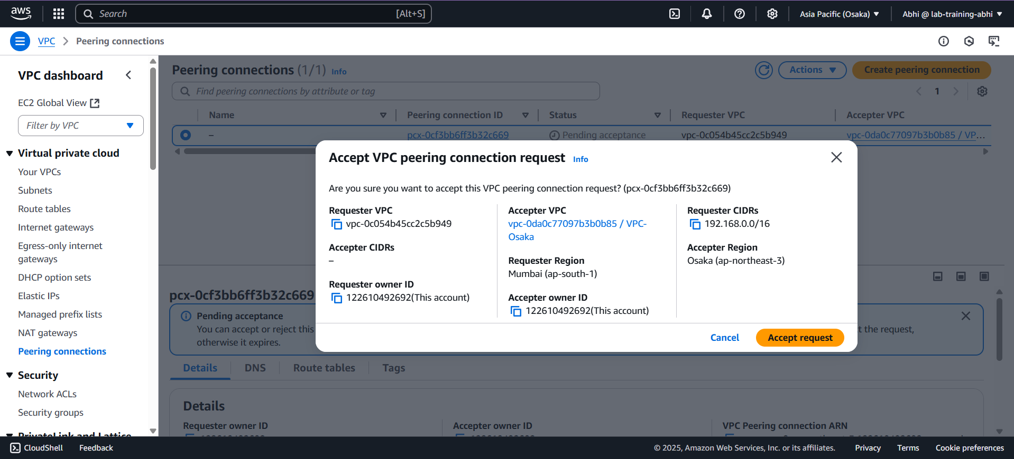

**NOW THE VPC PEERING CONNECTION IS ESTABLISHED AND IT IS ACTIVE :**

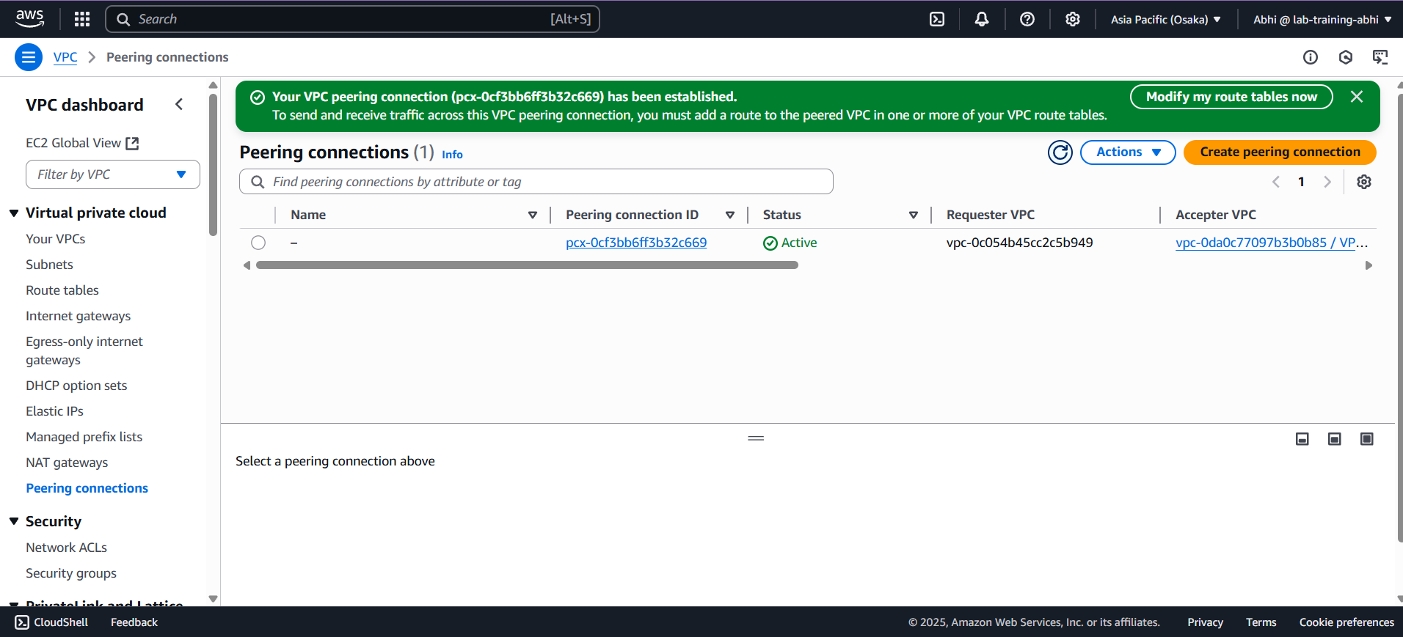

**CREATE THE ROUTE TABLE FOR VPC MUMBAI :**

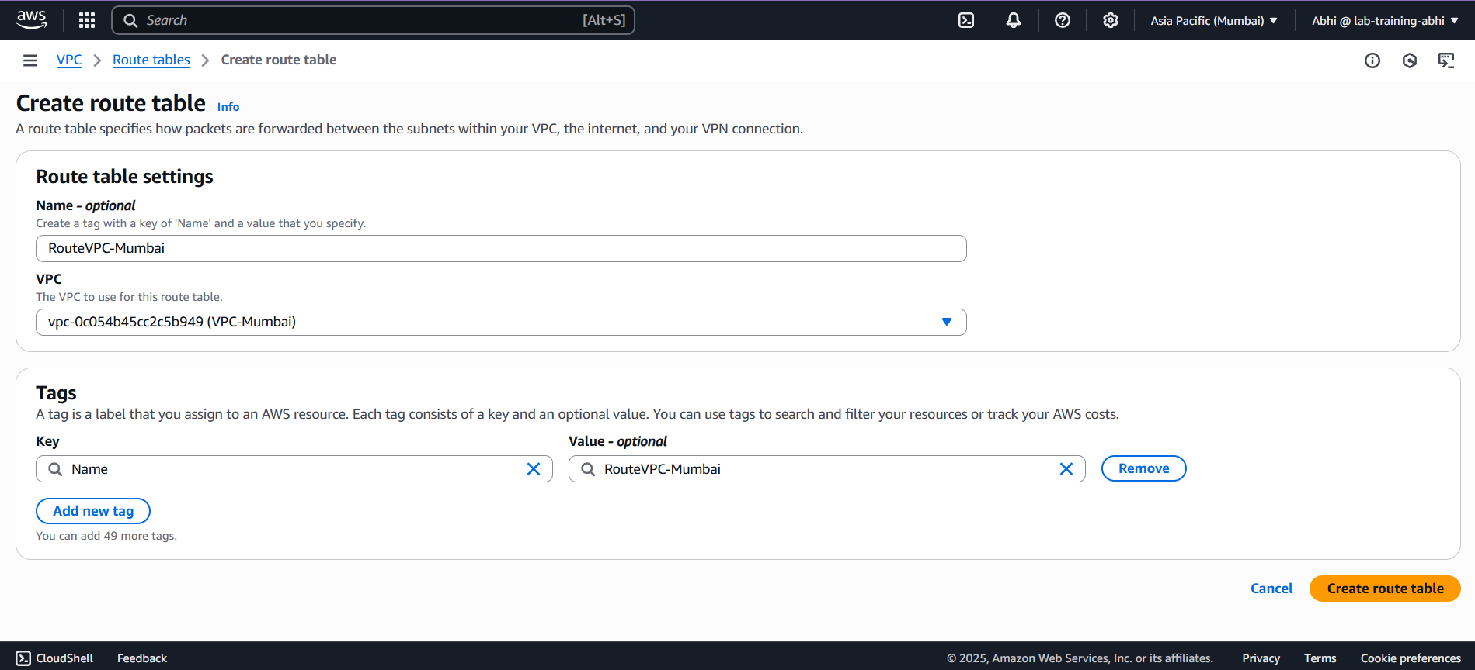

**ADDING THE ROUTE OF PEERING CONNECTION & INTERNET GATEWAY:**

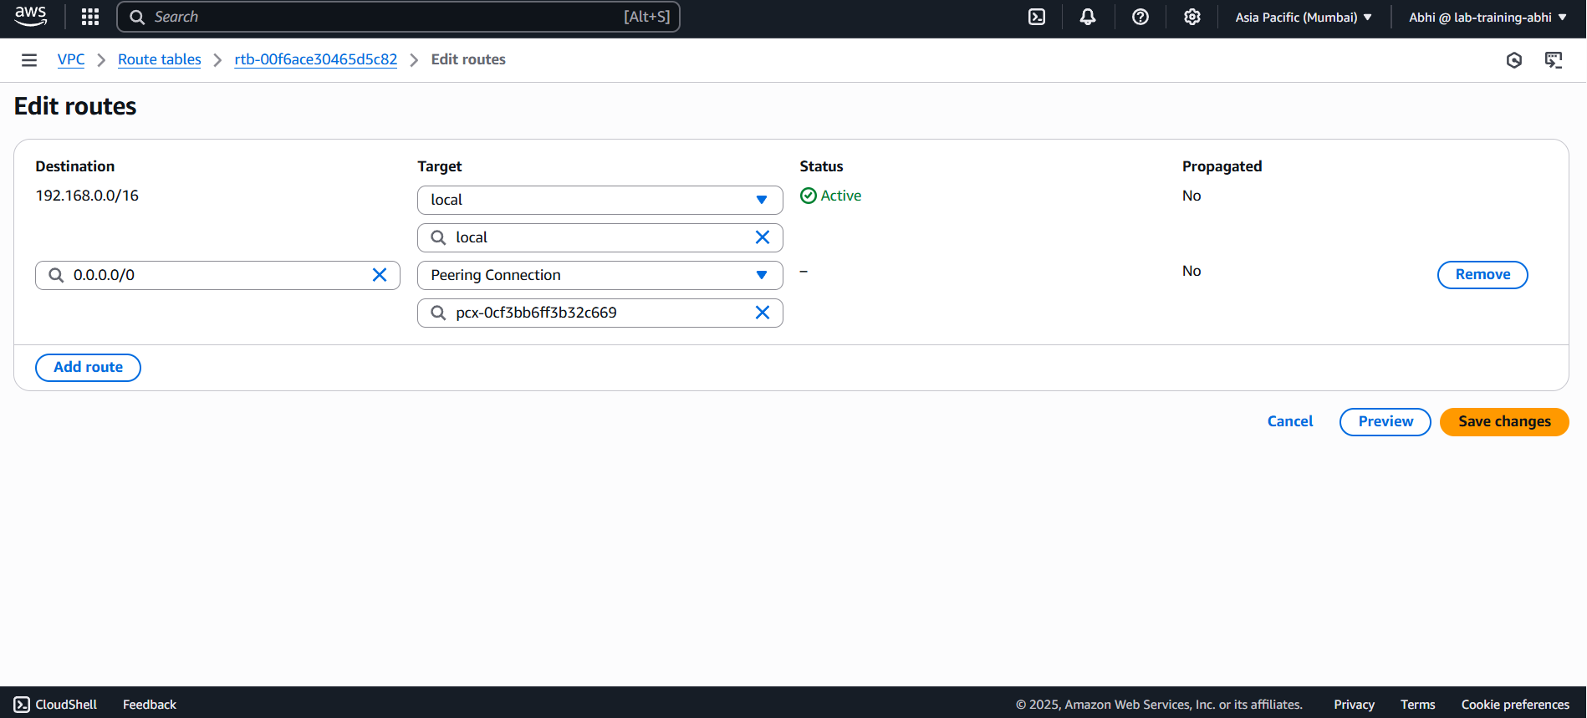

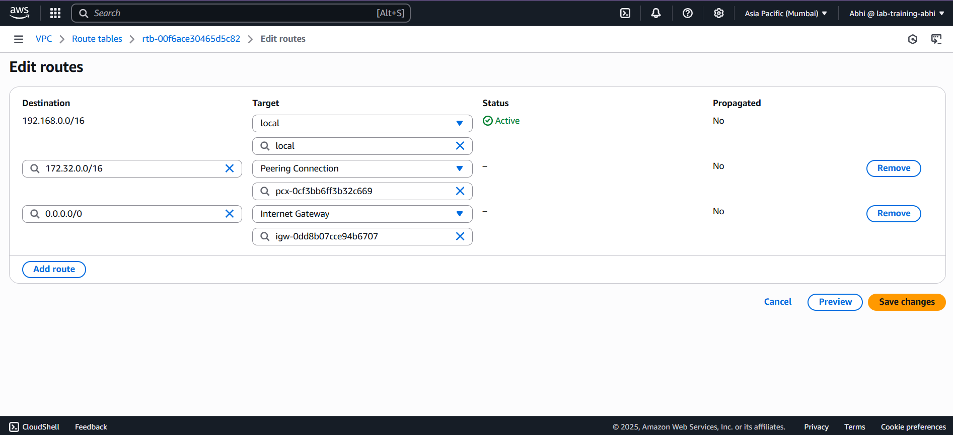

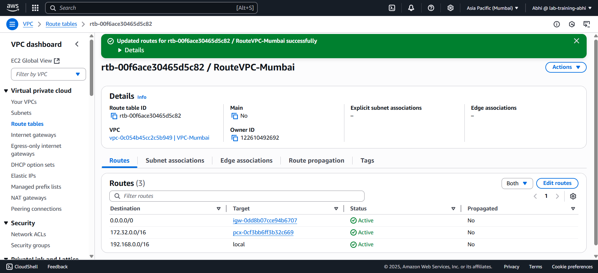

**ASSOCIATE THE SUBNET WITH ROUTE TABLE :**

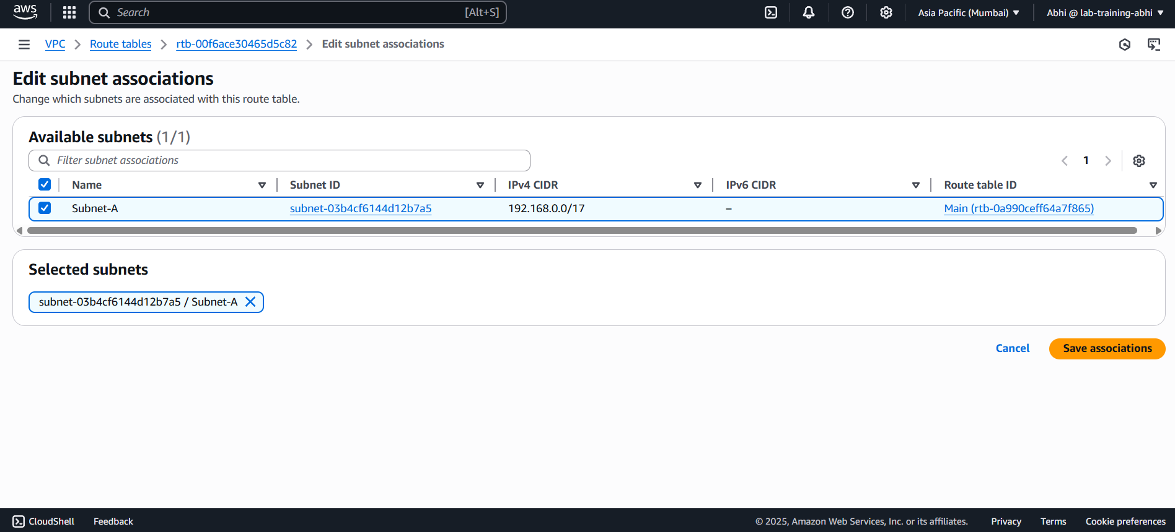

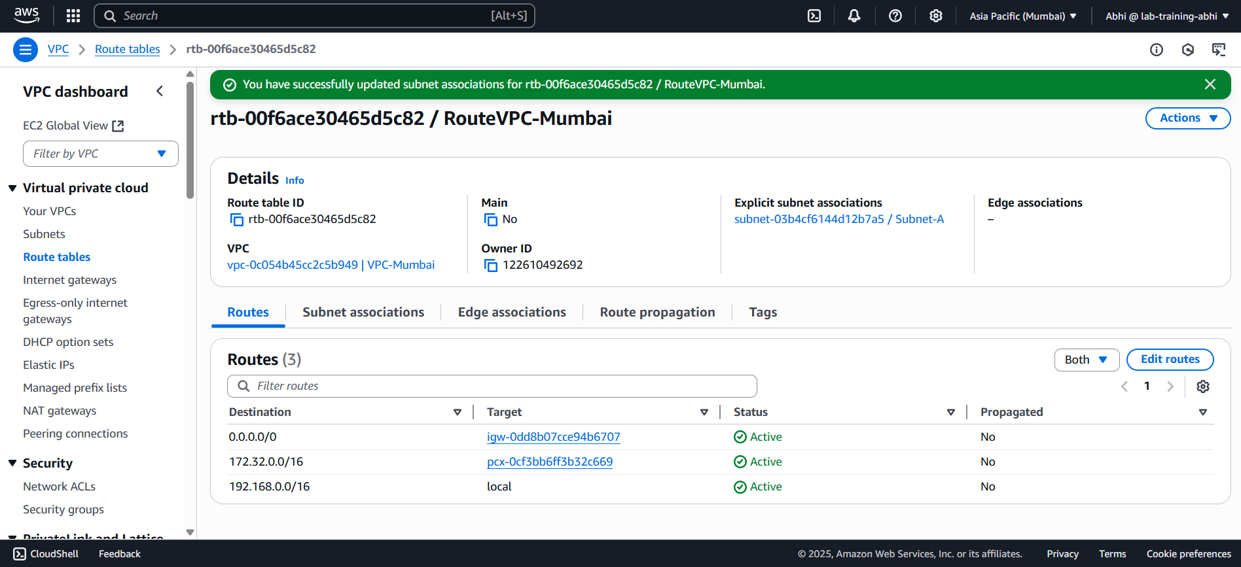

**CREATE THE ROUTE TABLE FOR VPC-OSAKA:**

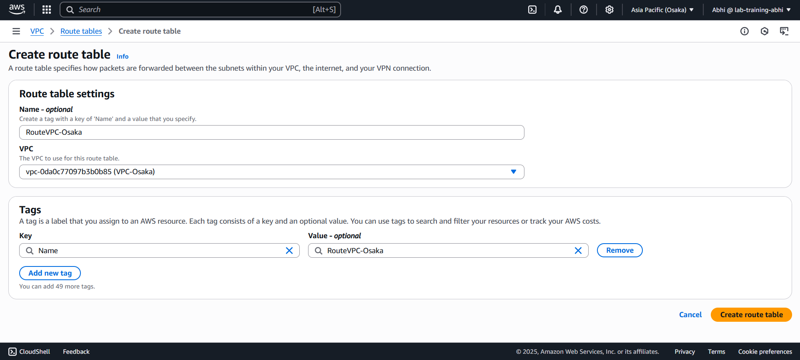

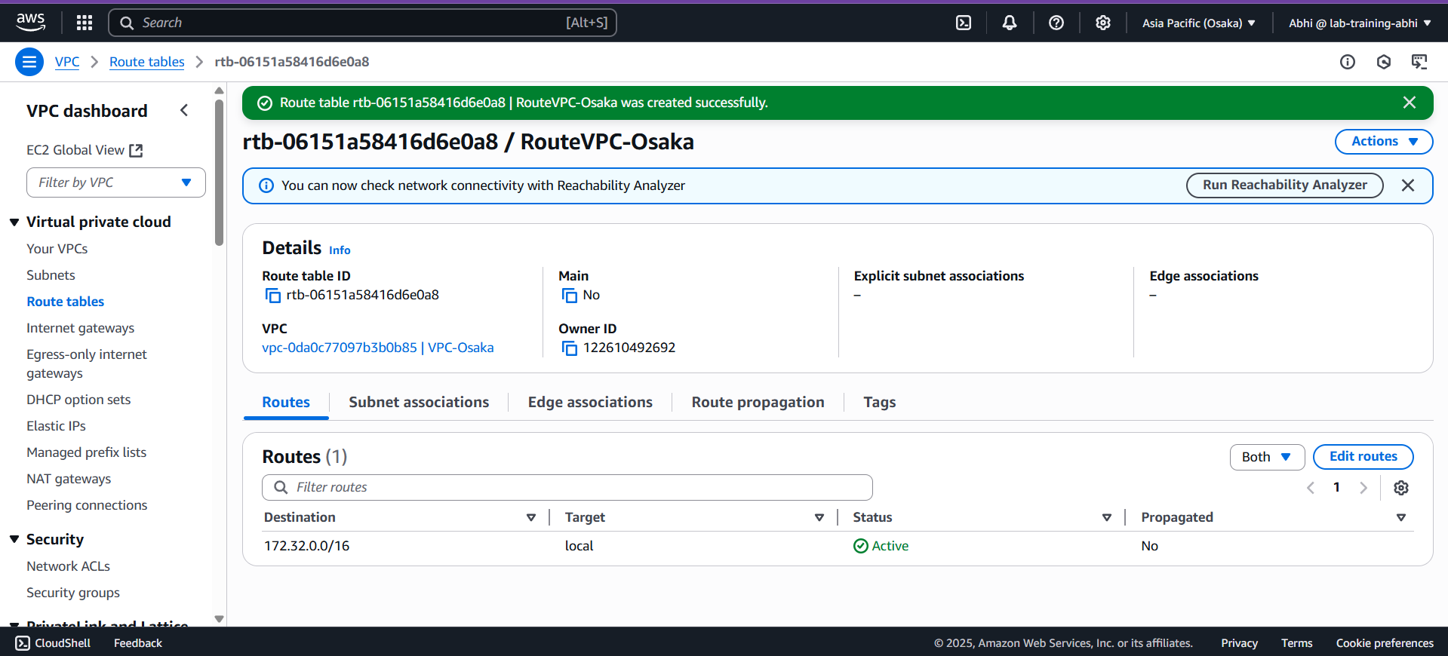

**ADDING THE ROUTE OF PEERING CONNECTION & INTERNET GATEWAY:**

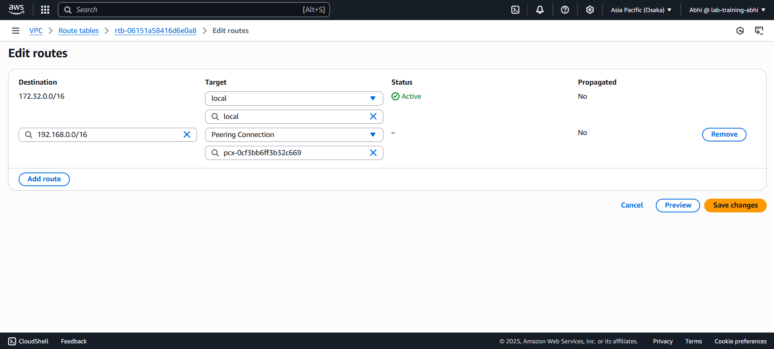

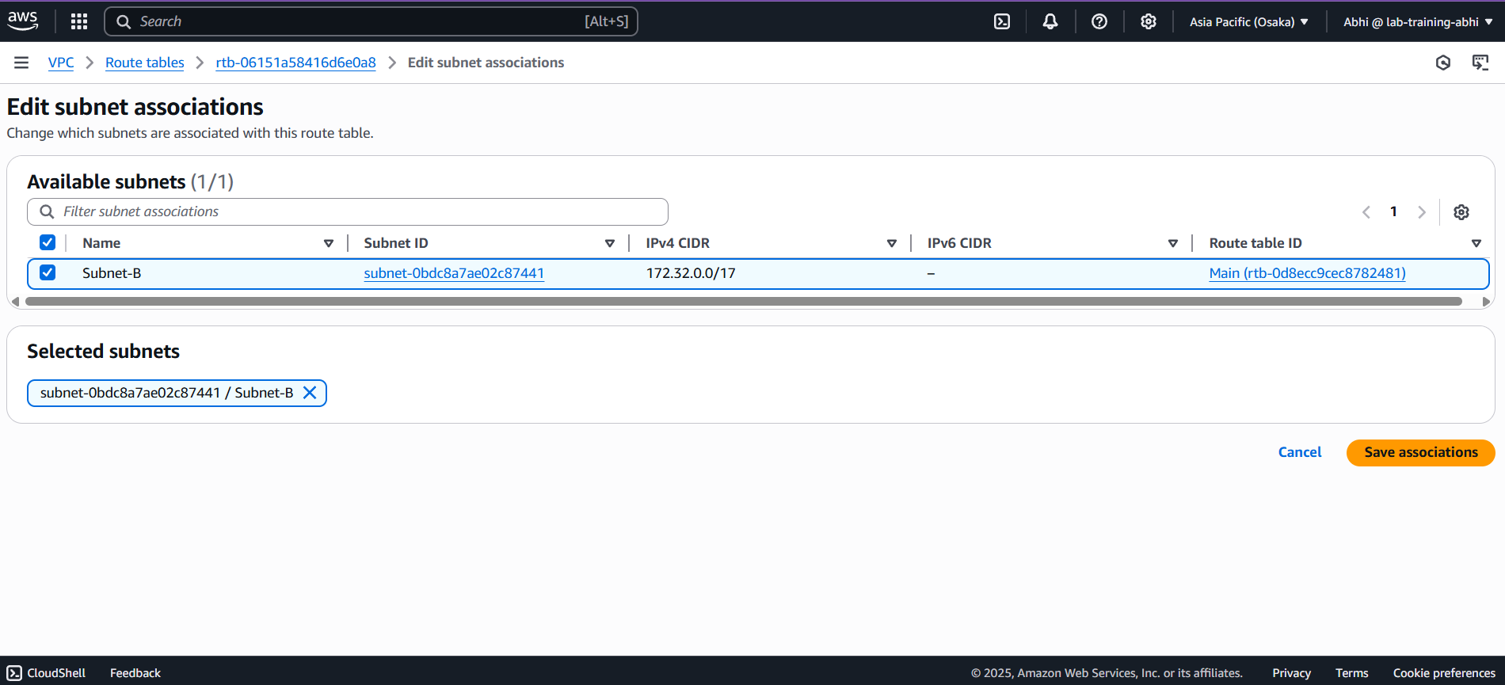

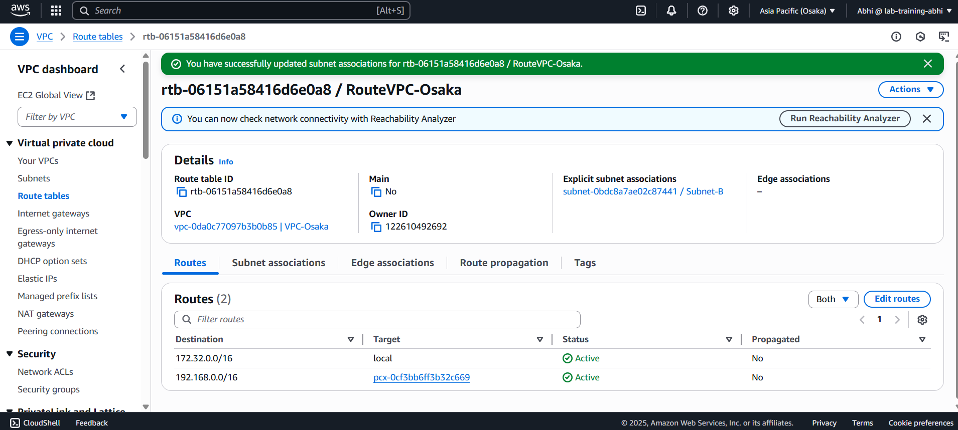

**NOW LAUNCH AN INSTANCE IN MUMBAI REGION AS PUBLIC-SERVER :**

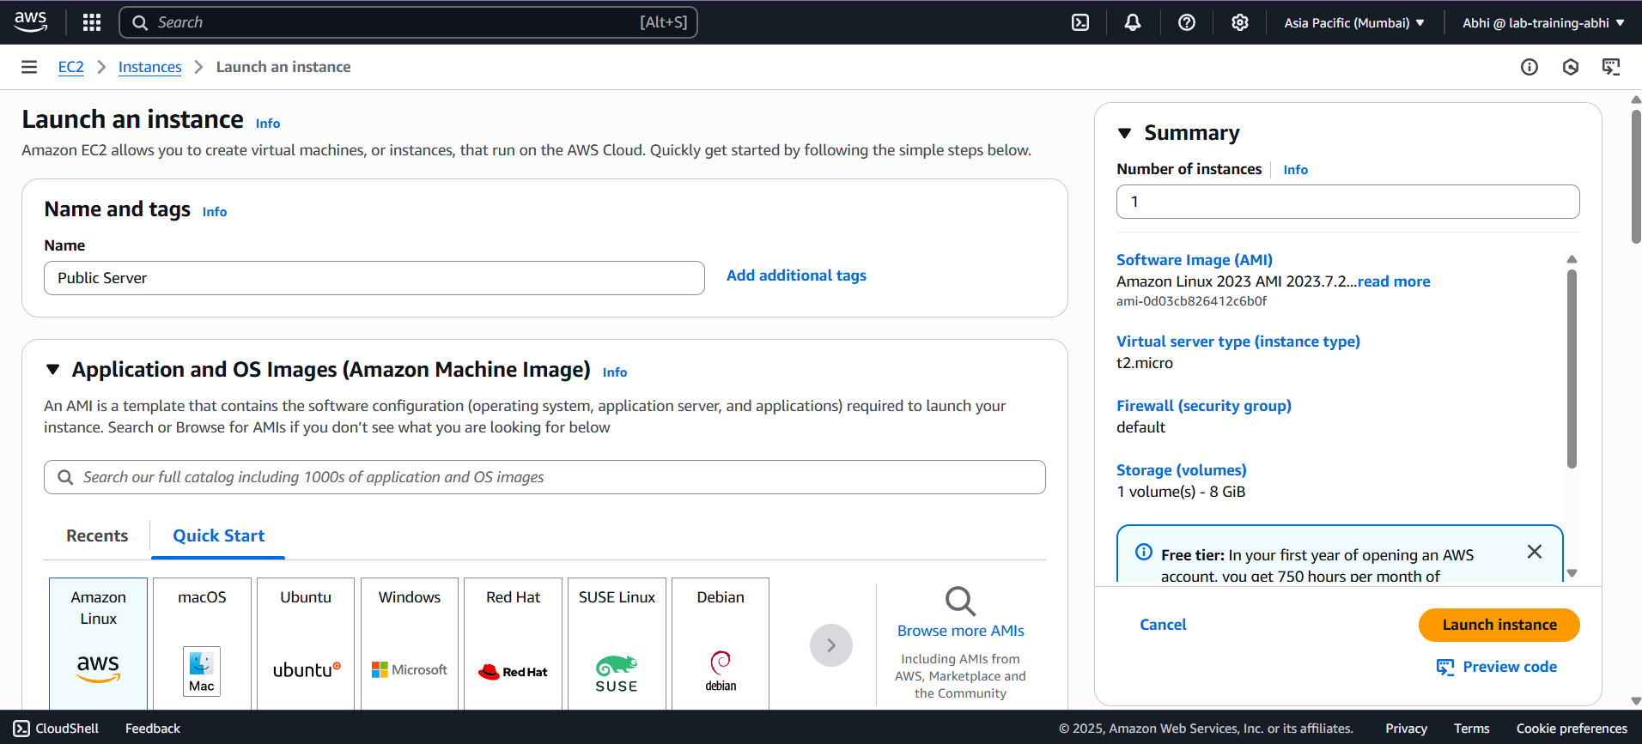

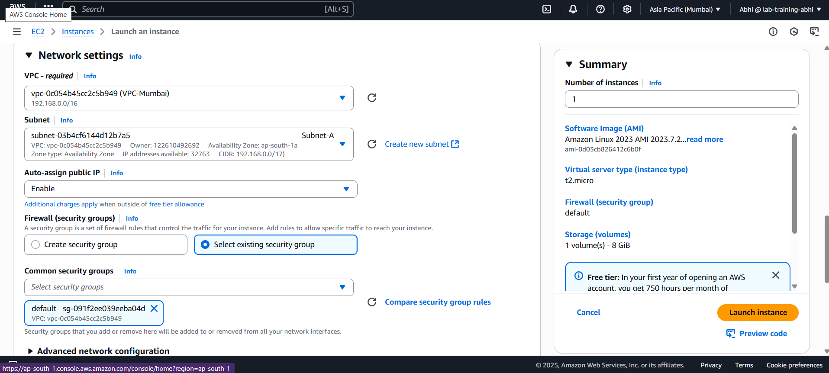

**NOW LAUNCH THE INSTANCE IN OSAKA REGION AS PRIVATE-SERVER :**

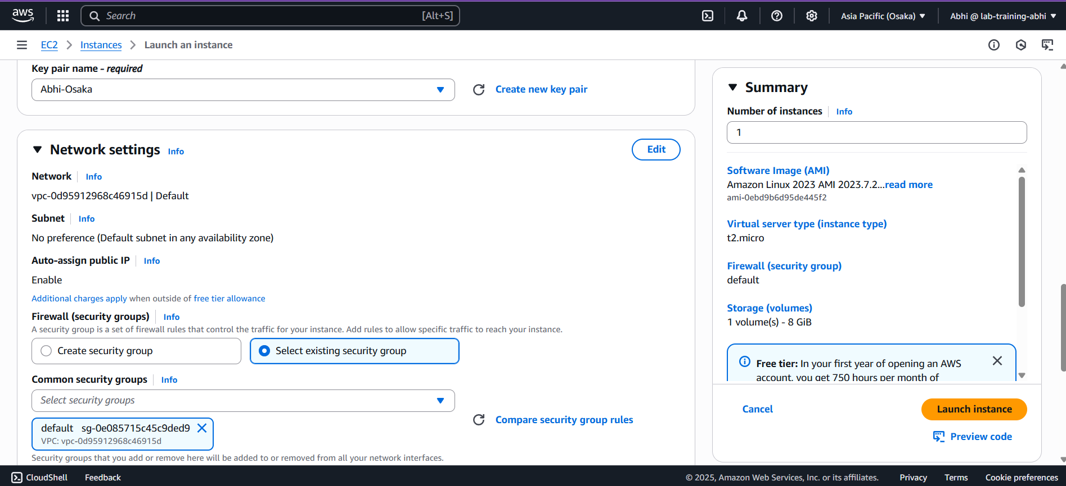

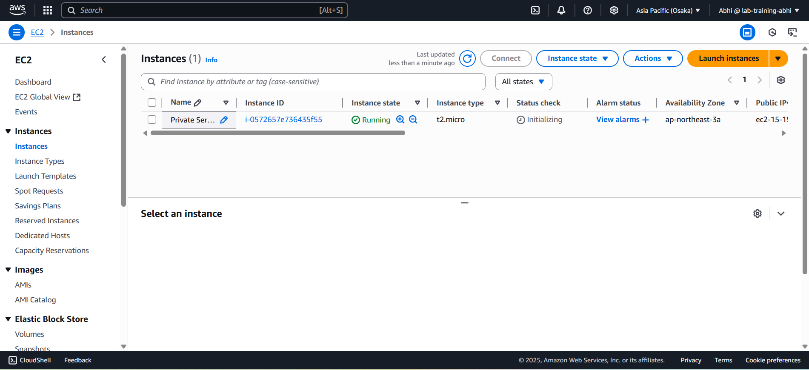

**NOW CONNECT THE INSTANCE OF PUBLIC-SERVER :**

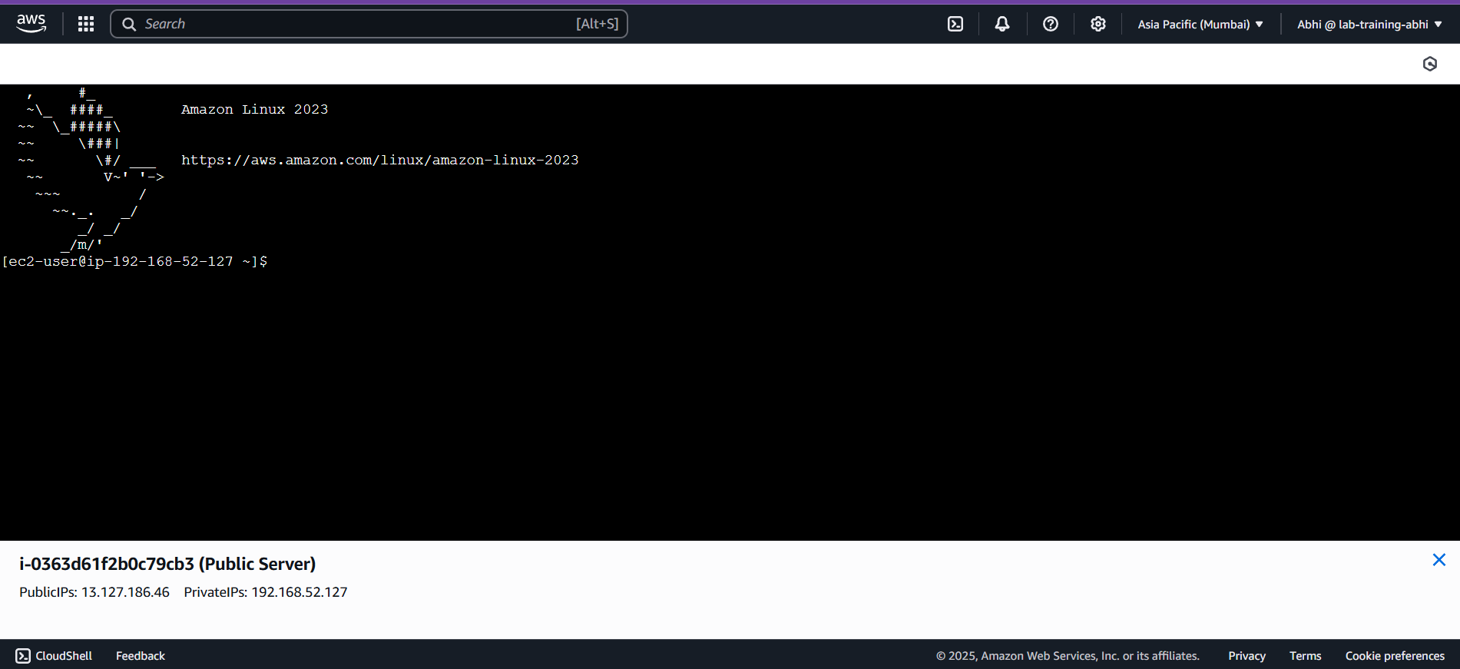

**NOW TEST THE CONNECTIVITY OF THE SERVER :**

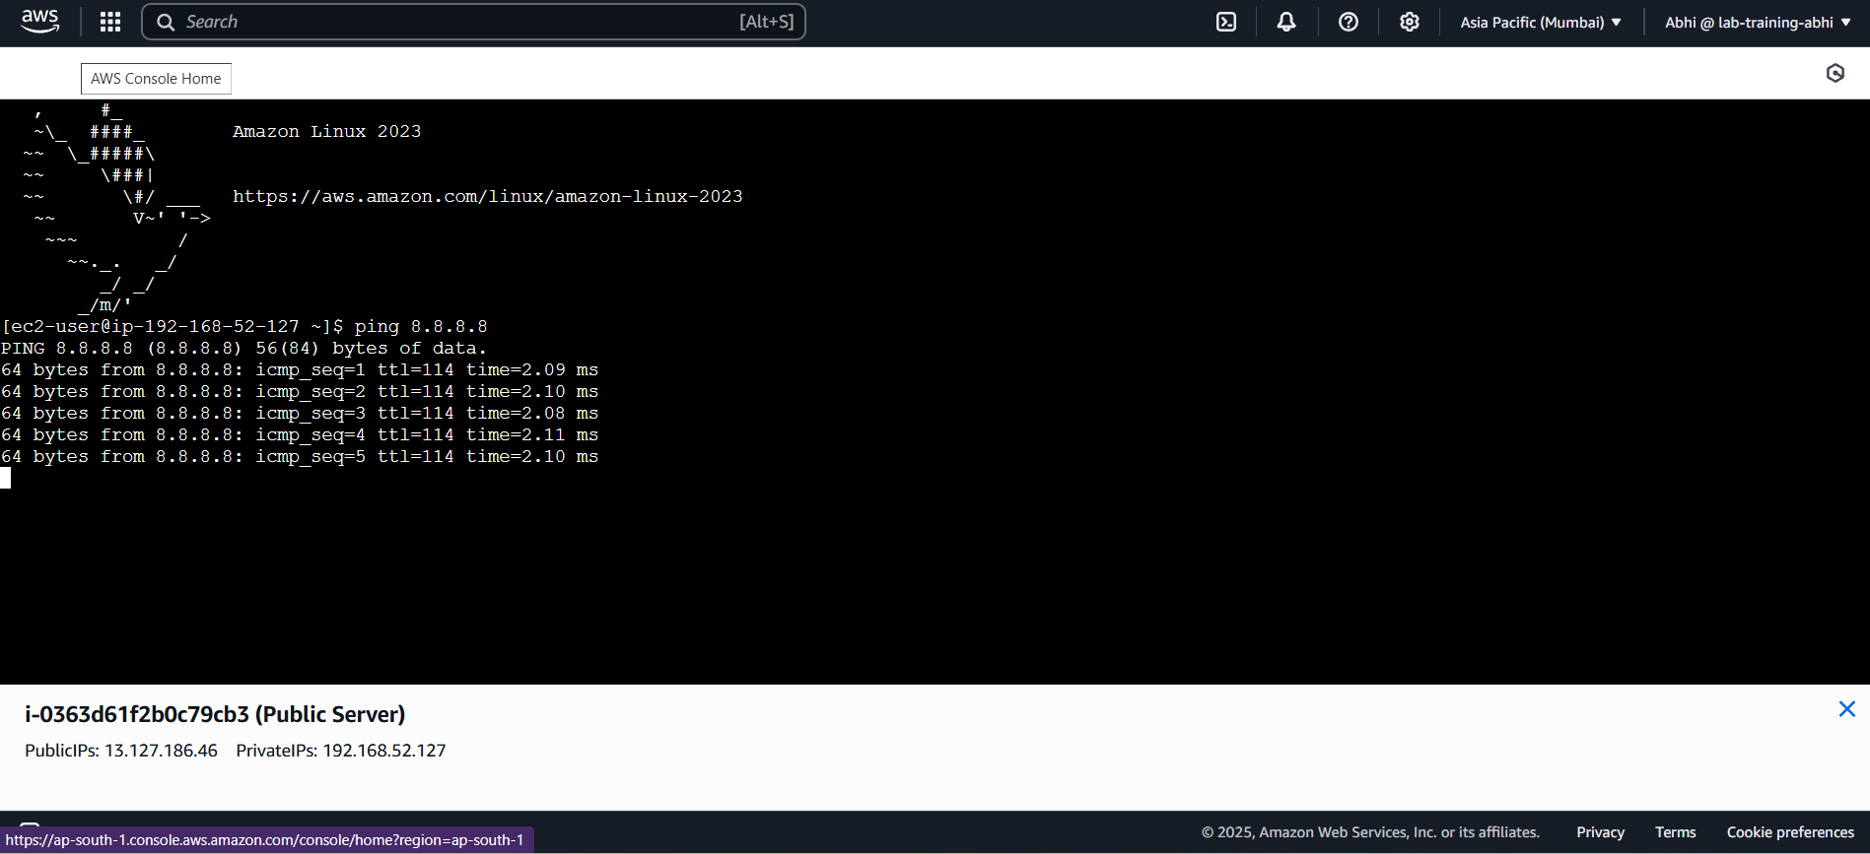

**TAKE THE ACCESS OF PRIVATE-SERVER ON PUBLIC SERVER BY USING THE KEY :**

